**Change Hardware compatibility of a VM (Either by clone/create new one) which is already created and configured.**

**AIM:**

To Change Hardware compatibility of a VM (Either by clone/create new one) which is already created and configured.

**PROCEDURE:**

**STEP 1:**

First install VMware workstation in your pc/laptop. Then open the VM software and click create a new virtual machine displayed on a home tab.

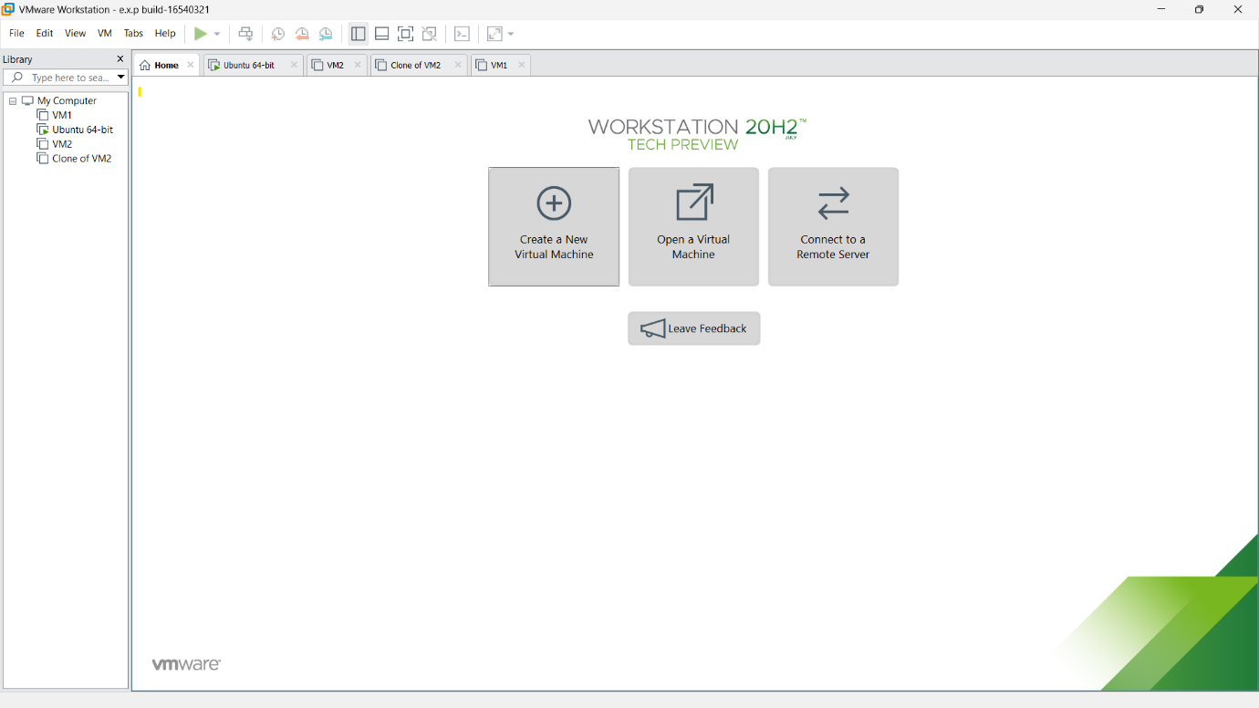

**STEP 2:**

Then right click any VM which was aready created.in that select manage option.in manage option select clone.

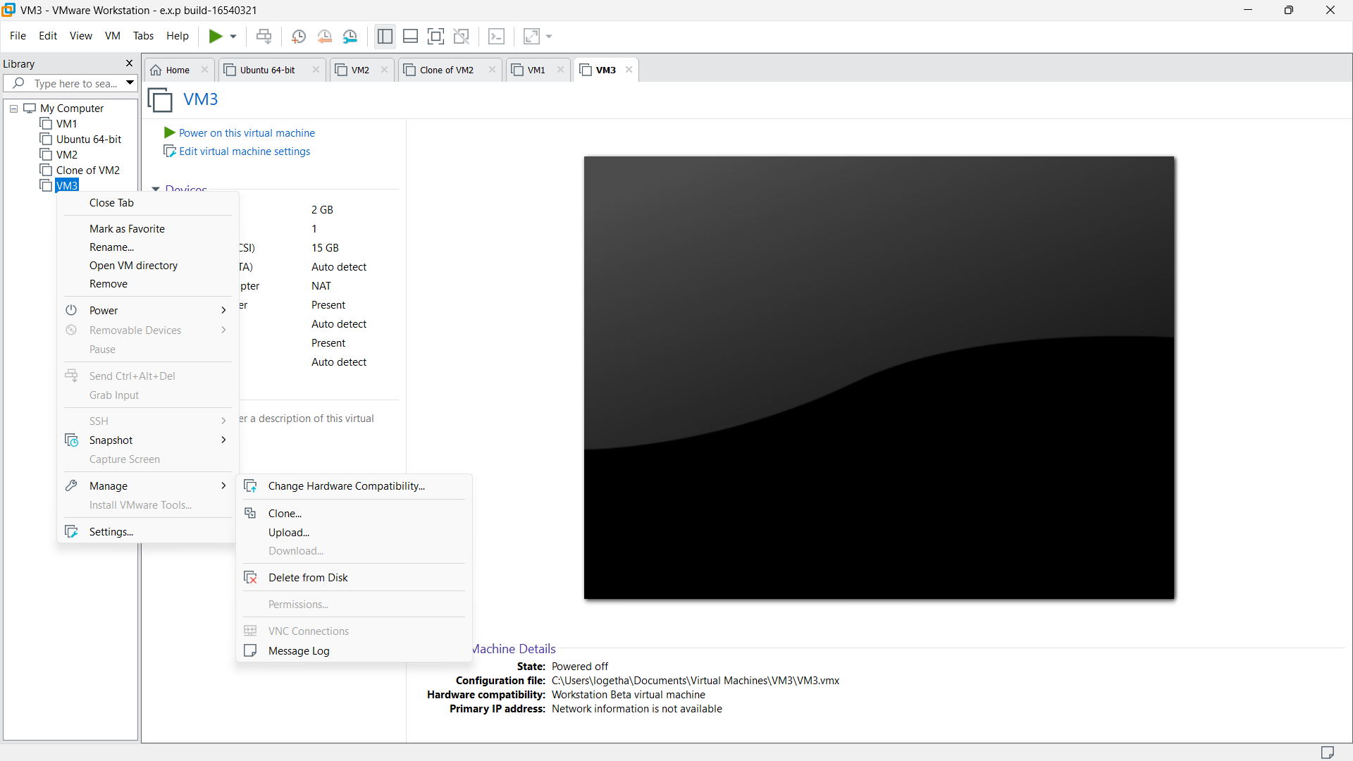

**STEP 3:**

Below attached message will be displayed.click next .

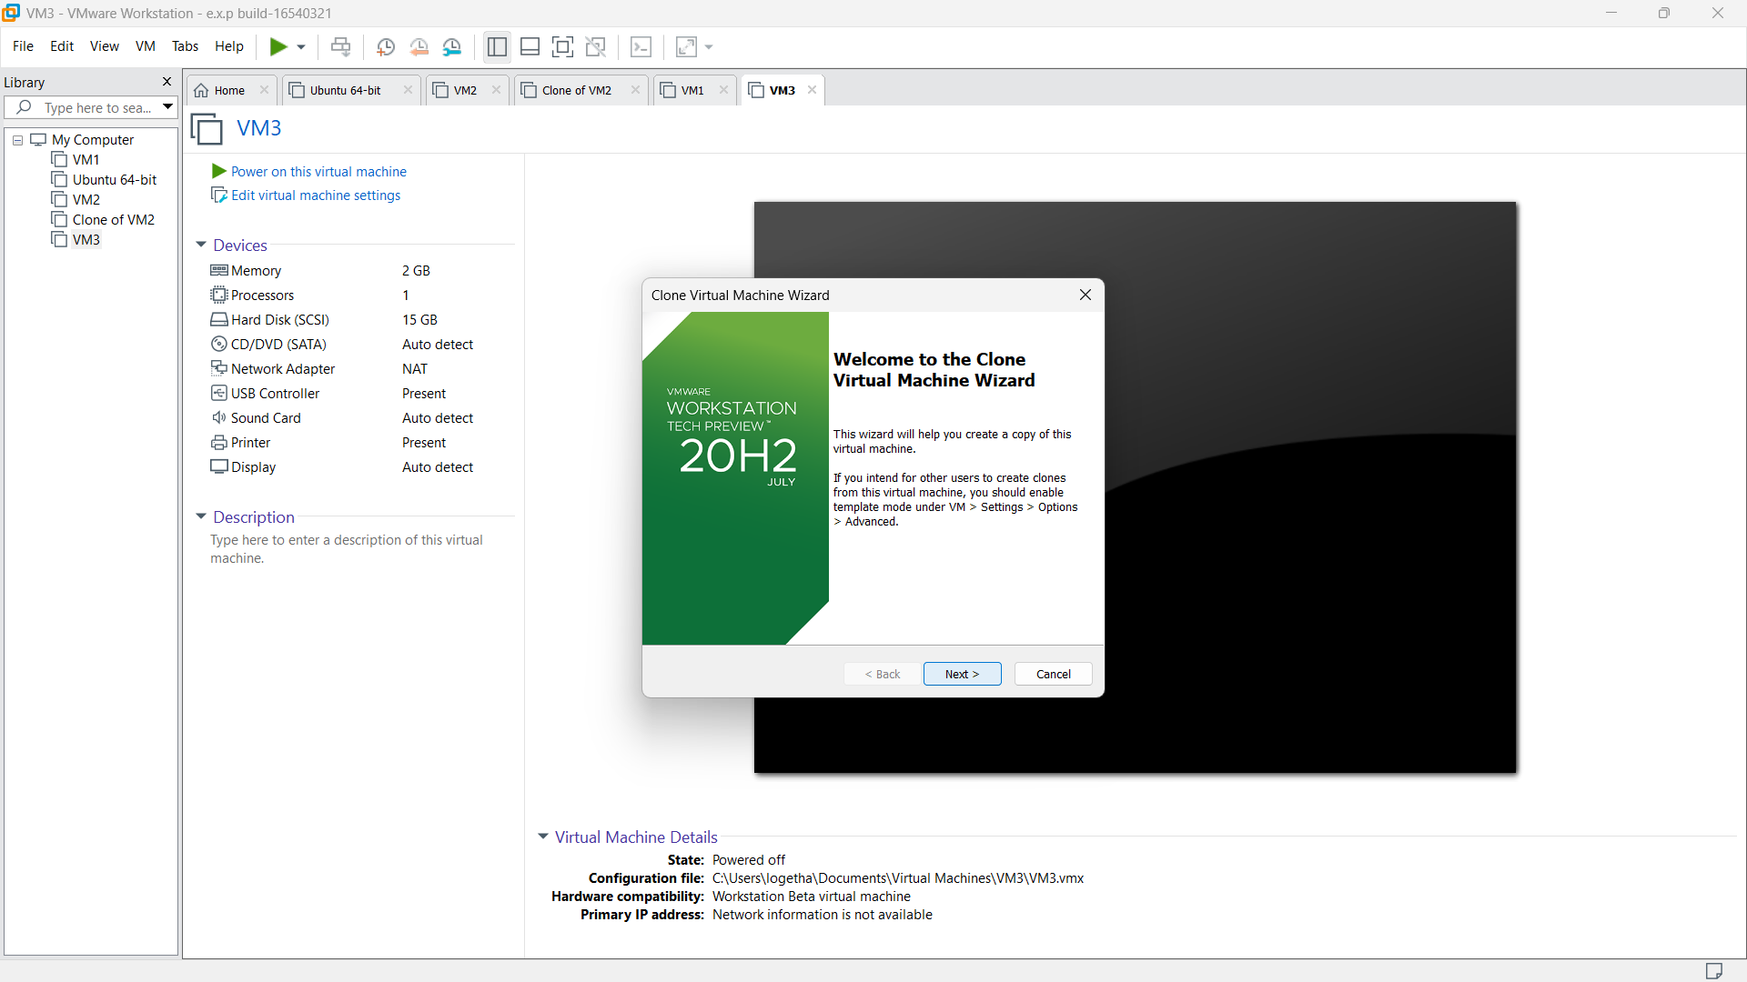

**STEP 4:**

Then select the default option and click next.

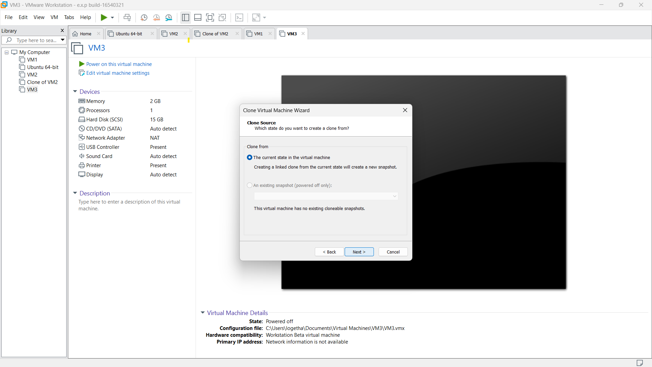

**STEP 5:**

Then select create a full clone option because we are going to create a new separate clone for the selected VM. And click next.

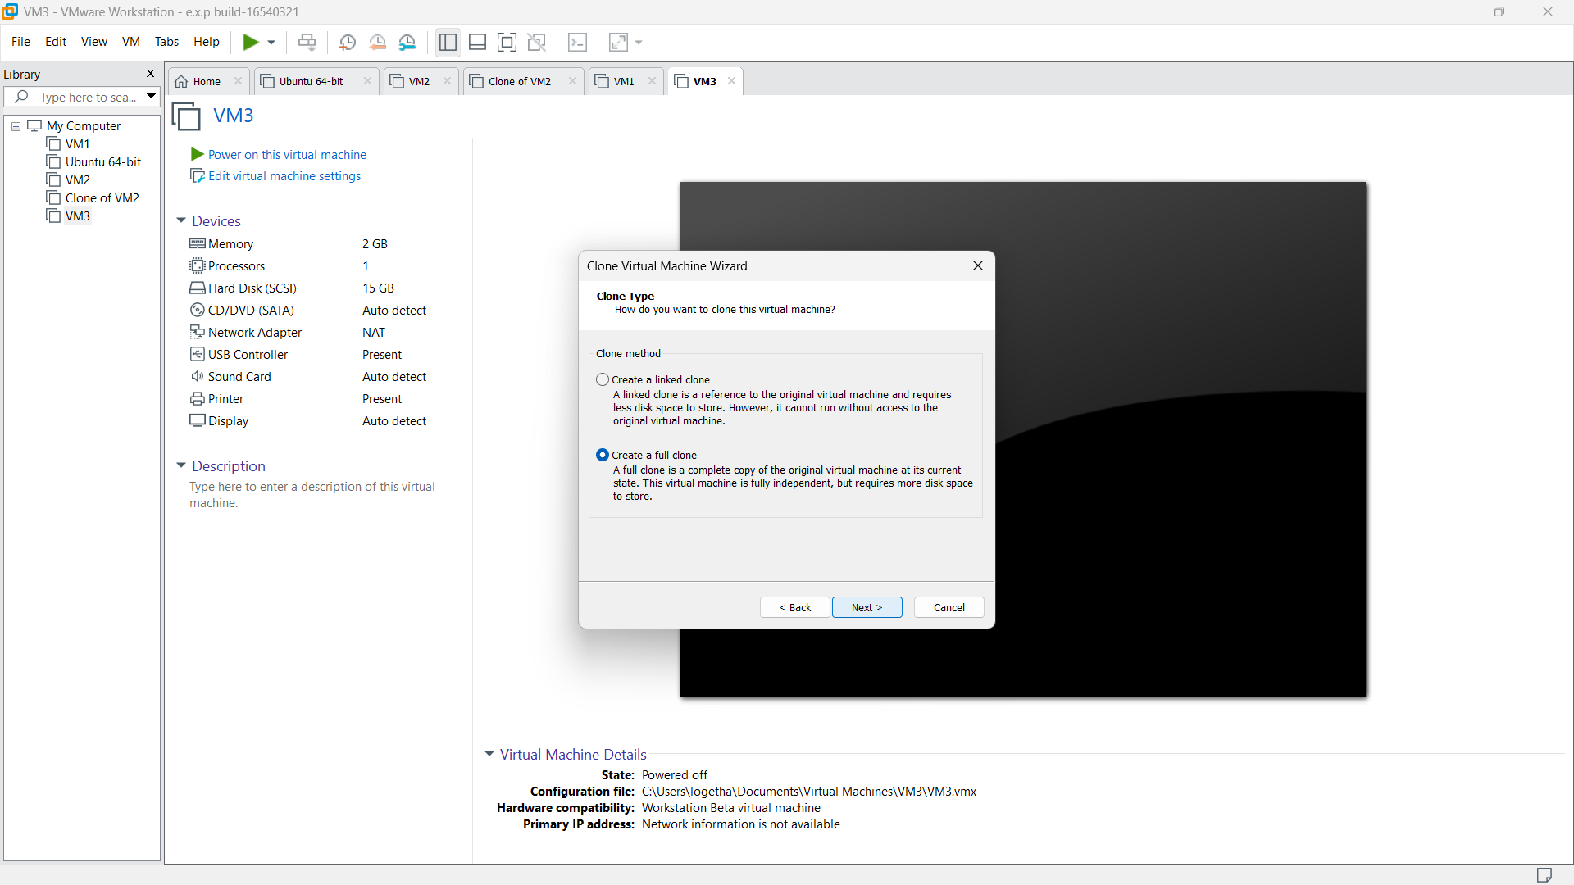

**STEP 6:**

then provide appropriate name for the clone VM and click finish.

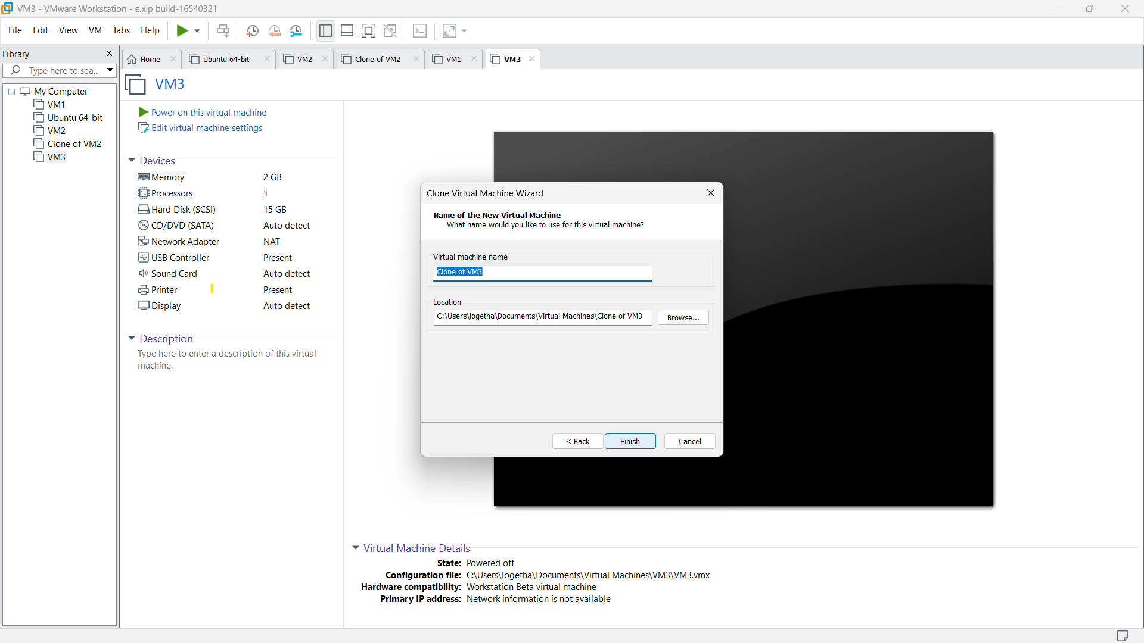

**STEP 7:**

Cloned VM with the specification will be displayed.

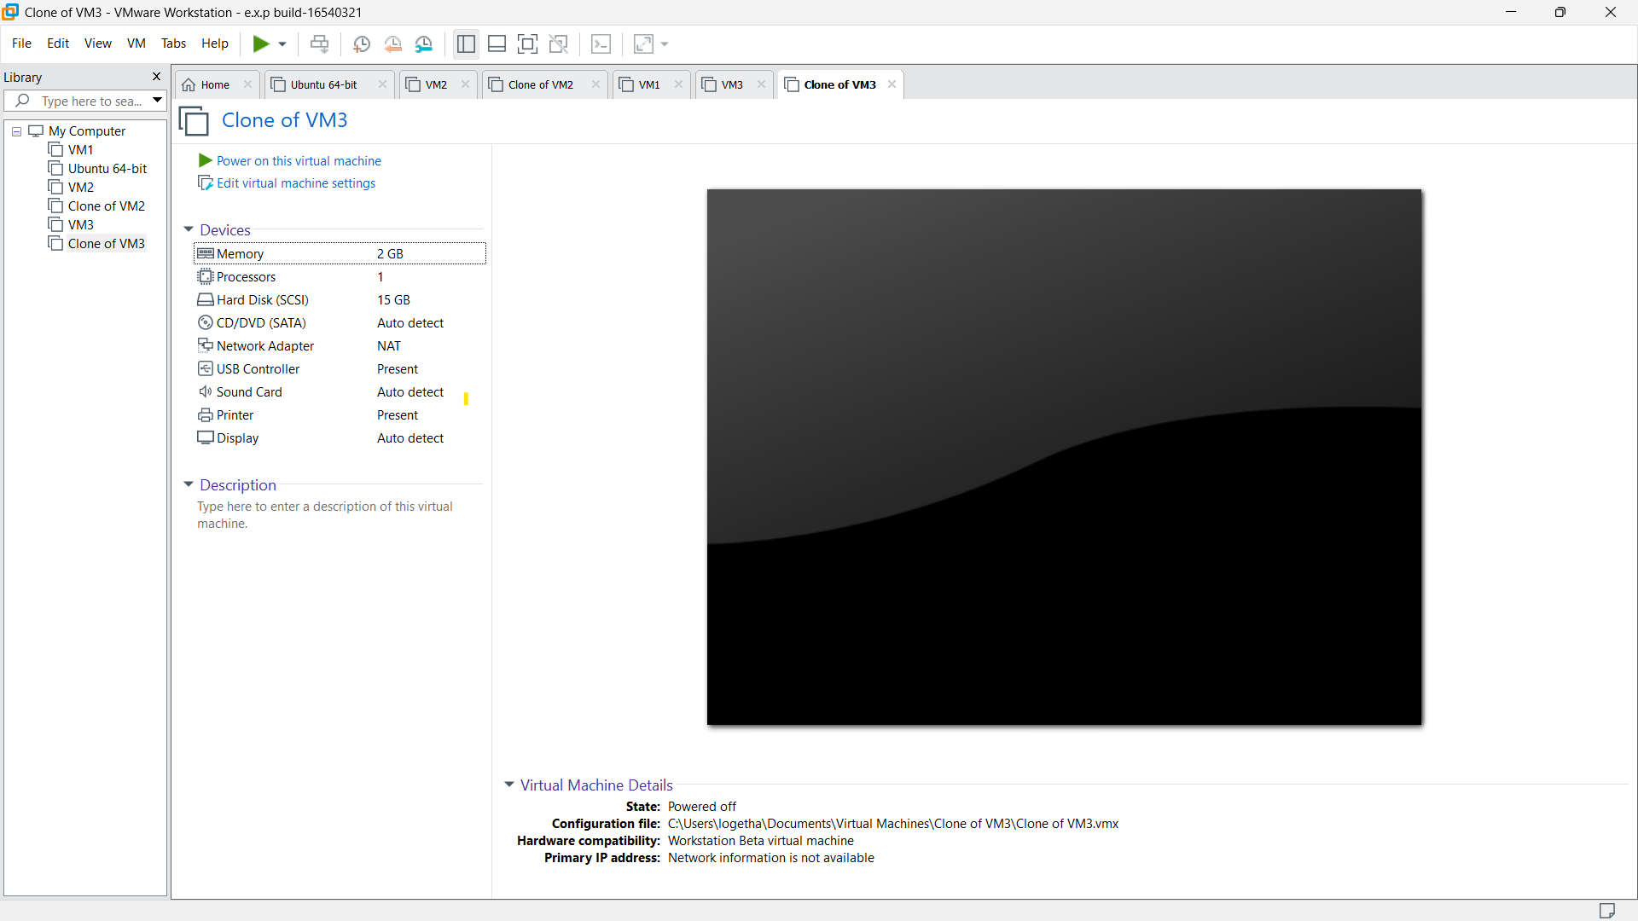

**STEP 8:**

Now click any of the hardware specification of the cloned VM.

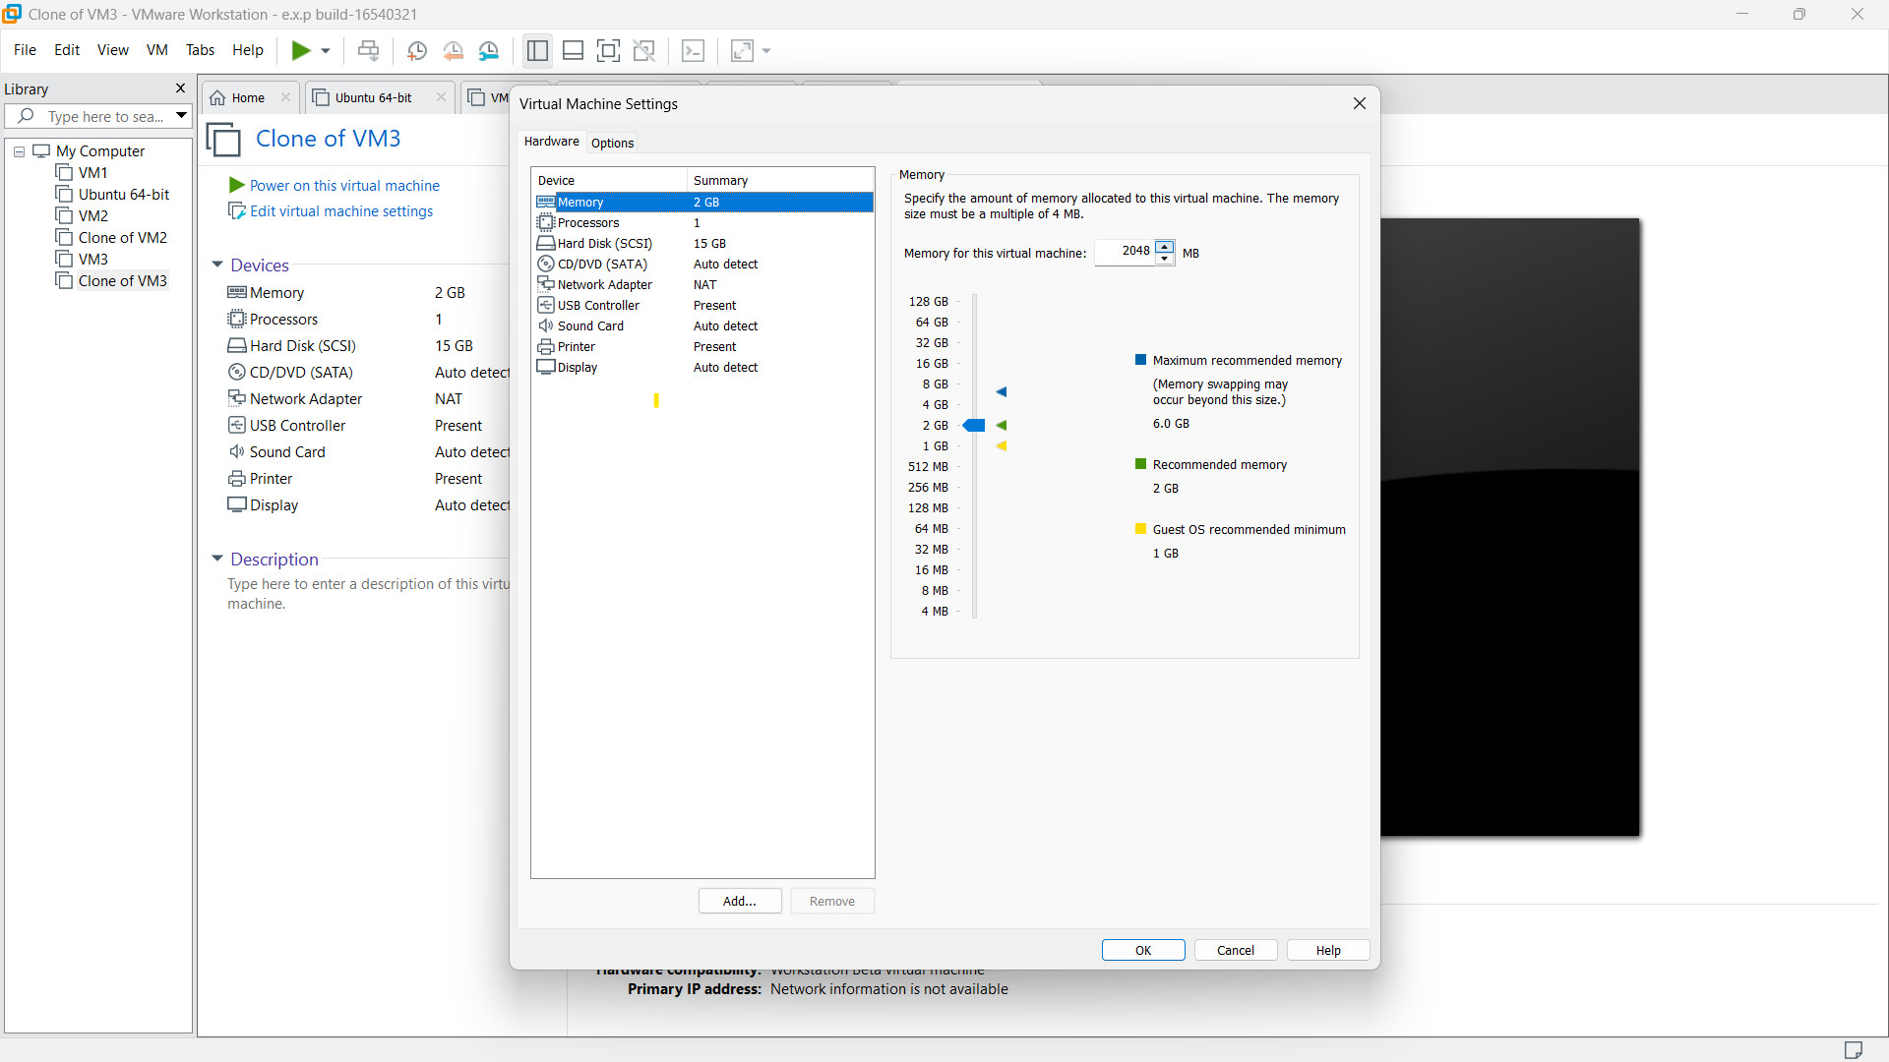

**STEP 9:**

then change the specification of any hardware of cloned VM as our requirements. Finally click OK

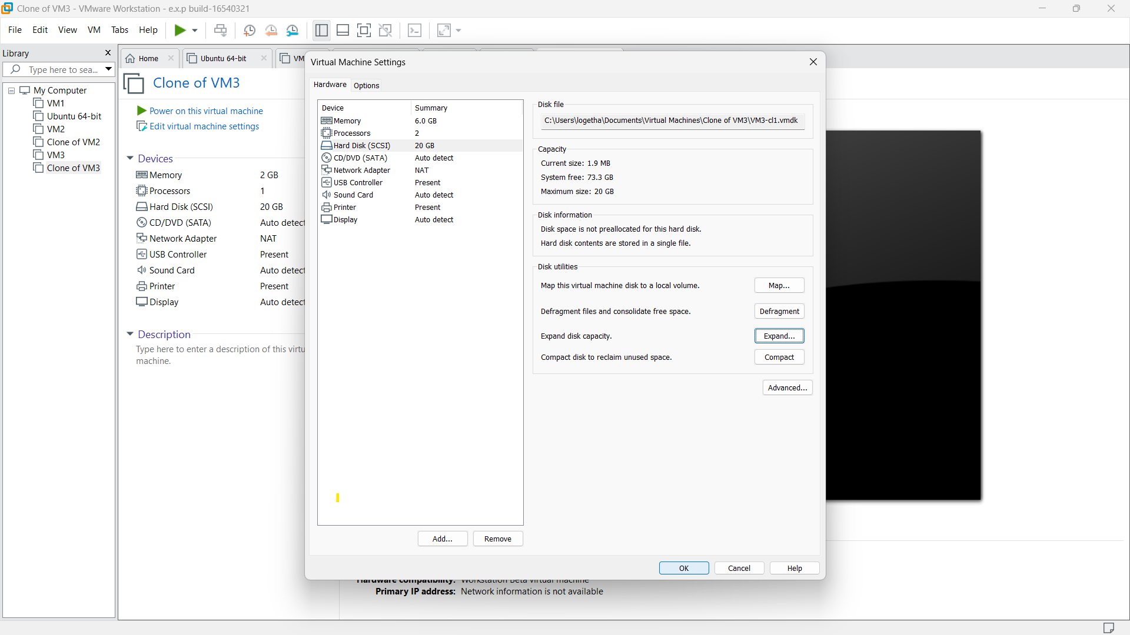

**STEP 10:**

Cloned VM with our required specification will be displayed.

